The Kidney

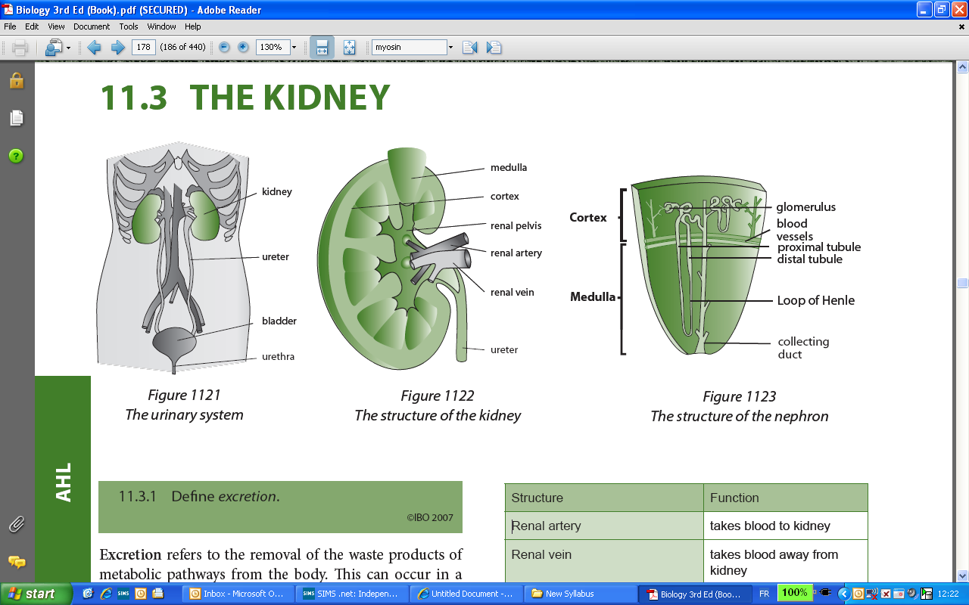

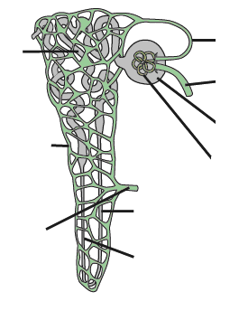

On the diagrams above label the parts listed in the table below and then complete the functions

Structure | Function
Renal artery
Renal Vein
Afferent vessel
Efferent vessel
Vasa recta
Glomerulus
Bowman’s (renal) capsule
Proximal convoluted tubule
Loop of Henle
Distal convoluted tubule
Collecting duct
Define Osmoregulation

Complete the table below to summarise the 5 steps in the formation of urine.

Step | Summary
1. Ultrafiltration | Ultrafiltration –  Blood pressure –  Podocytes -
2. Selective reabsorption in the proximal convoluted tubule | Osmosis -  Active transport –  Facilitated diffusion –  Diffusion –  Pinocytosis –
3. Water in the loop of Henle | Concentration of salts –  Countercurrent multiplier mechanism (a diagram could help) –
4. Distal convoluted tubule | pH of blood (be very brief) –  selective ion absorption –
5. Water reabsorption in the collecting ducts | ADH -  Permeability of the walls –

Complete the table below to compare the relative concentrations of substances in the following solutions. Only use High, Low or None.

Solution | Concentration
Solution | Glucose | Proteins | Urea
Plasma

Glomerular fitrate

Urine

What is different about the composition of the urine of a diabetic?

