Human Joints

Use p361 to 365 Biology for the IB Diploma (Clegg)

Complete the table below to summarise the role of the components of the human locomotory system

Structure | Role
Bones
Ligaments
Muscles
Tendons
Nerves

Label the diagram of the elbow joint below (cartilage, synovial fluid, synovial membrane, joint capsule, humerus, radius and ulna). Add the biceps and triceps muscle and tendons.
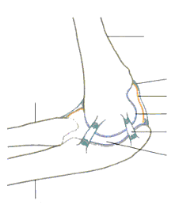
Complete the table below to explain the functions of the elbow joint components

Component | Function
Bones
Biceps
Triceps
Ligaments
Capsule
Synovial membrane
Synovial Fluid
Cartilage

Complete the table below to compare the hip and knee joint

Hip Joint |  | Knee joint
 | Type
 | Moving bones
 | Additional bones
 | Moving surface
 | Type of movement

