IB Biology – HL Topic 11 Human Physiology - REPRODUCTION

A high quality image of a human blastocyst.  The cells which will become the fetus are in the area marked as "ICM" (inner cell mass)  The cavity in the center is marked as "C"  The trophectoderm cells that will form the placenta surround the cavity - one is marked with a "T" | 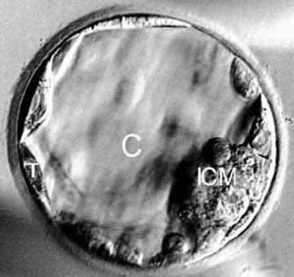  Source: 

Outline the development of a Blastocyst. Refer to Mitosis, differentiation of cells, and the cavity.

For each pair of cells – describe what is happening to the embryo….

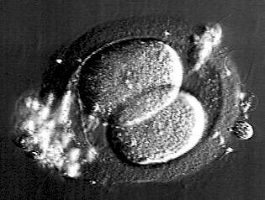  A high quality 2-cell embryo | 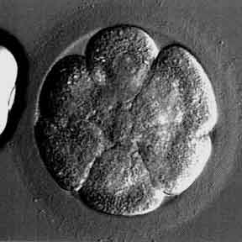  A high quality 8-cell embryo  6 cells are seen in the plane of focus  Another cell is in the centre, above the plane of focus -  with a little imagination you can see it
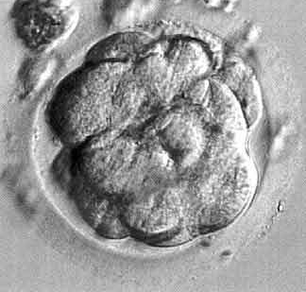  High quality day 4 embryo from in vitro fertilization  It contains about 10 - 30 cells. This is the final stage prior to formation of a fluid filled cavity when it is called an early blastocyst. | 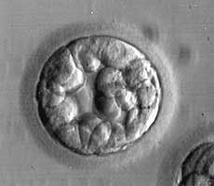  Cavity very small  Inner cell mass – unclear  Trophectoderm not formed yet
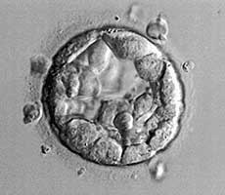  Cavity > 1/2 embryo's volume  Inner cell mass – Several cells, loosely grouped  Trophectoderm Few cells, forming a loose epithelium | 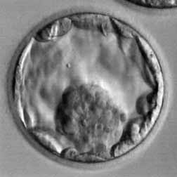  Expanded blastocyst, cavity larger than the embryo  Inner cell mass = Many cells, tightly packed  Trophectoderm = Few cells, forming a loose epithelium
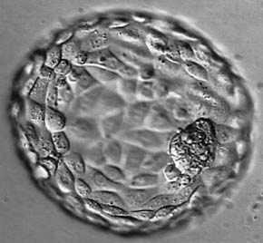  Expanded blastocyst, cavity larger than the embryo  Inner cell mass = Many cells, tightly packed  Trophectoderm = many cells, forming a cohesive epithelium | What is involved in embryo implantation?  - Successful implantation requires a competent blastocyst embryo interacting with  a receptive endometrial (uterus) lining.  When does blastocyst implantation actually occur after an IVF cycle - or in a normal menstrual cycle?  - Implantation occurs on day 6-10 after the egg retrieval  - Which is 1 to 5 days after a blastocyst transfer  - Which is equivalent to day 20-24 of a natural menstrual cycle (idealized 28 day cycle)  How long does embryo implantation take?  - Once the blastocyst has hatched out of its shell, the actual attachment and invasion of embryonic cells should begin within a day.

