
Topic 11: Human health and physiology (17 hours)

11.1Defence against infectious disease 4 hours
11.1.1 Describe the process of blood clotting. 2
Limit this to the release of clotting factors from platelets and damaged cells resulting in the formation of thrombin. Thrombin catalyses the conversion of soluble fibrinogen into the fibrous protein fibrin, which captures blood cells.

11.1.2 Outline the principle of challenge and response, clonal selection and memory cells as the basis of immunity. 2
This is intended to be a simple introduction to the complex topic of immunity. The idea of a polyclonal response can be introduced here.
Challenge
Response:

Clonal selection:

Memory cells

polyclonal response

11.1.3 Define active and passive immunity. 1
Active immunity is immunity due to the production of a____________ by the organism itself after the body’s defence mechanisms have been stimulated by antigens.
Passive immunity is immunity due to the acquisition of antibodies from ___________________ __________in which active immunity has been stimulated, including via the placenta, colostrum, or by injection of antibodies.
11.1.4 Explain antibody production. 3
antigen presentation by macrophages

and activation of helper T-cells leading to

activation of B-cells which divide to form clones of antibody-secreting plasma cells and memory cells.

11.1.5 Describe the production of monoclonal antibodies and their use in diagnosis and in treatment. 2
the fusion of tumour and B-cells,

proliferation and production of antibodies.

one example of diagnosis
one example of treatment.
Detection of antibodies to HIV is one example in diagnosis. Others are detection of a specific cardiac isoenzyme in suspected cases of heart attack and detection of human chorionic gonadotrophin (HCG) in pregnancy test kits. Examples of the use of these antibodies for treatment include targeting of cancer cells with drugs attached to monoclonal antibodies, emergency treatment of rabies, blood and tissue typing for transplant compatibility, and purification of industrially made interferon.

11.1.6 Explain the principle of vaccination. 3
Emphasize the role of memory cells. The primary and secondary responses can be clearly illustrated by a graph.
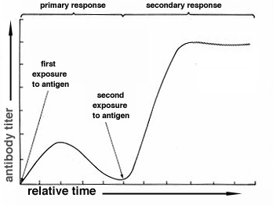

Precise details of all the types of vaccine (attenuated virus, inactivated toxins, and so on) for specific diseases are not required.
11.1.7 Discuss the benefits and dangers of vaccination. 3
The benefits:
- total elimination of diseases,
- prevention of pandemics and epidemics,
- decreased health-care costs and
- prevention of harmful side-effects of diseases.
The dangers:
- possible toxic effects of mercury in vaccines,
- possible overload of the immune system and
- possible links with autism.

11.2 Muscles and movement 4 hours

11.2.1 State the roles of bones, ligaments, muscles, tendons and nerves in human movement. 1

11.2.2 Label a diagram of the human elbow joint, including cartilage, synovial fluid, joint capsule, named bones and antagonistic muscles (biceps and triceps). 1

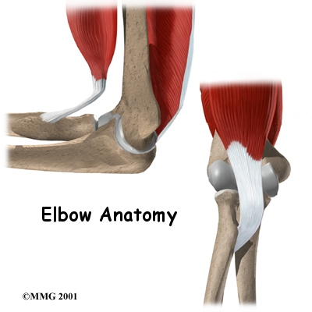

11.2.3 Outline the functions of the structures in the human elbow joint named in 11.2.2. 2
11.2.4 Compare the movements of the hip joint and the knee joint. 3
Hip joint | Knee joint
11.2.5 Describe the structure of striated muscle fibres, including the myofibrils with light and dark bands, mitochondria, the sarcoplasmic reticulum, nuclei and the sarcolemma. 2

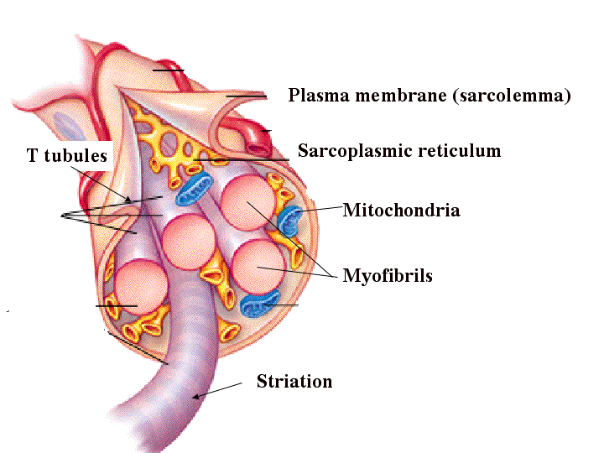

11.2.6 Draw and label a diagram to show the structure of a sarcomere, including Z lines, actin filaments, myosin filaments with heads, and the resultant light and dark bands. 1
No other terms for parts of the sarcomere are expected.

11.2.7 Explain how skeletal muscle contracts, including the release of calcium ions from the sarcoplasmic reticulum, the formation of cross-bridges, the sliding of actin and myosin filaments, and the use of ATP to break cross-bridges and re-set myosin heads. 3
Details of the roles of troponin and tropomyosin are not expected.

11.2.8 Analyse electron micrographs to find the state of contraction of muscle fibres. 3
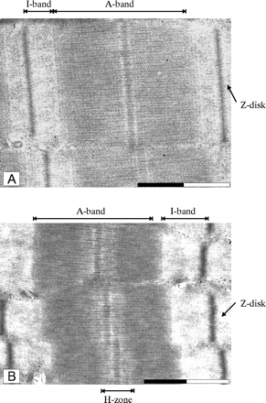
Muscle fibres can be fully relaxed, slightly contracted, moderately contracted and fully contracted.

11.3The kidney 4 hours

11.3.1 Define excretion. 1
Excretion is the removal from the body of the waste products of metabolic pathways.
11.3.2 Draw and label a diagram of the kidney. 1
Include the cortex, medulla, pelvis, ureter and renal blood vessels.

11.3.3 Annotate a diagram of a glomerulus and associated nephron to show the function of each part. 2

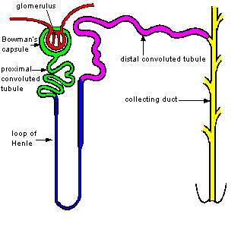

11.3.4 Explain the process of ultrafiltration, including

blood pressure,

fenestrated blood capillaries and

basement membrane. 3

11.3.5 Define osmoregulation. 1
Osmoregulation is the control of the water b________ of the blood, tissue or cytoplasm of a living organism.
11.3.6 Explain the reabsorption of glucose, water and salts in the proximal convoluted tubule, including the roles of microvilli, osmosis and active transport. 3

11.3.7 Explain the roles of the loop of Henle, medulla, collecting duct and ADH (vasopressin) in maintaining the water balance of the blood. 3 Details of the control of ADH secretion are only required in option H (see H.1.5).

11.3.8 Explain the differences in the concentration of proteins, glucose and urea between blood plasma, glomerular filtrate and urine. 3

11.3.9 Explain the presence of glucose in the urine of untreated diabetic patients. 3

11.4 Reproduction 5 hours

11.4.1 Annotate a light micrograph of testis tissue to show the location and function of interstitial cells (Leydig cells), germinal epithelium cells, developing spermatozoa and Sertoli cells. 2

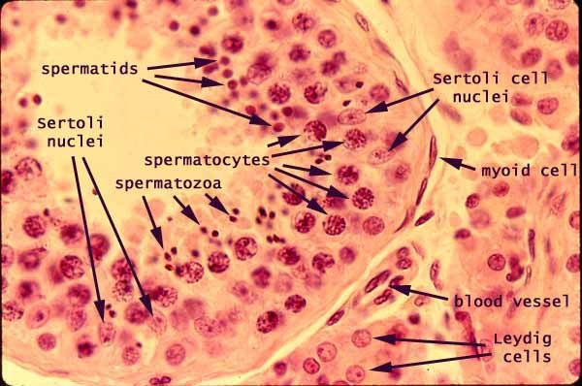

11.4.2 Outline the processes involved in spermatogenesis within the testis, including mitosis, cell growth, the two divisions of meiosis and cell differentiation. 2
The names of the intermediate stages in spermatogenesis are not required.

11.4.3 State the role of LH, testosterone and FSH in spermatogenesis. 1

11.4.4 Annotate a diagram of the ovary to show the location and function of germinal epithelium, primary follicles, mature follicle and secondary oocyte. 2

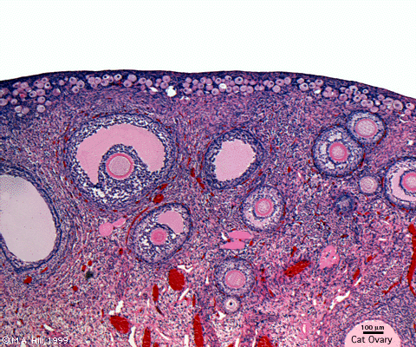

11.4.5 Outline the processes involved in oogenesis within the ovary, including mitosis, cell growth, the two divisions of meiosis, the unequal division of cytoplasm and the degeneration of polar body. 2
The terms oogonia and primary oocyte are not required.

11.4.6 Draw and label a diagram of a mature sperm and egg. 1

11.4.7 Outline the role of the epididymis, seminal vesicle and prostate gland in the production of semen. 2

11.4.8 Compare the processes of spermatogenesis and oogenesis, including the number of gametes and the timing of the formation and release of gametes. 3

 | Spermatogenesis | Oogenesis
Number of gametes

Timing

Release of gametes

11.4.9 Describe the process of fertilization, including the acrosome reaction, penetration of the egg membrane by a sperm and the cortical reaction. 2

11.4.10 Outline the role of HCG in early pregnancy. 2

11.4.11 Outline early embryo development up to the implantation of the blastocyst. 2
Limit this to several mitotic divisions

resulting in a hollow ball of cells called the blastocyst.

11.4.12 Explain how the structure and functions of the placenta, including its hormonal role in secretion of estrogen and progesterone, maintain pregnancy. 3

11.4.13 State that the fetus is supported and protected by the amniotic sac and amniotic fluid. 1
Embryonic details of the fetus and the structure of amniotic membranes are not required.

11.4.14 State that materials are exchanged between the maternal and fetal blood in the placenta. 1

11.4.15 Outline the process of birth and its hormonal control, including the changes in progesterone and oxytocin levels and positive feedback. 2

