11.4 HL Reproduction Topic (part 1)

reference
http://www.slideshare.net/fernandasilva/114-reproduction-hl-ppt?from=ss_embed
Annotate a light micrograph of testis tissue to show the location and function of:  - interstitial cells (Leydig cells),  - germinal epithelium cells,  - developing spermatozoa and  - Sertoli cells.  This photomicrograph illustrates the typical structure of the testis showing the seminiferous tubules containing the germinal epithelial cells and Sertoli cells. The Leydig cells and blood vessels are found between the tubules  .  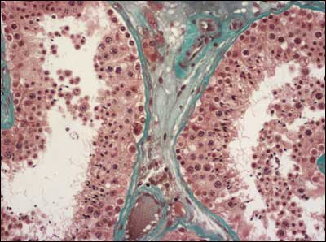  Source: www.endotext.org/male/ male1/figures/figure5.jpg  Label the cells in this photo of a seminiferous tubule in a testis.  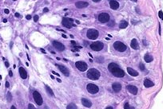 | 2
Outline the processes involved in spermatogenesis within the testis,  including: the names of cells and reason why the process happens.  mitosis, .....................................................................................................................................  cell growth, .....................................................................................................................................  the two divisions of meiosis .................................................................................  ..................................................  cell differentiation.  ..................................................................................................................................... | 2
State the role in spermatogenesis of  - LH ...................................................................................  - testosterone ...................................................................................  - FSH. ................................................................................... | 1

Annotate the diagram of the ovary to show the location and function of:  - germinal epithelium,  - primary follicles,  - mature follicle and  - secondary oocyte.  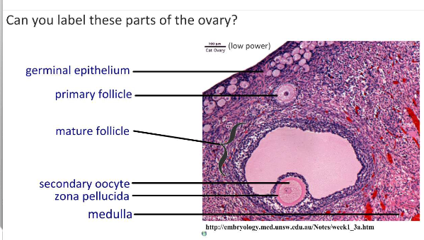  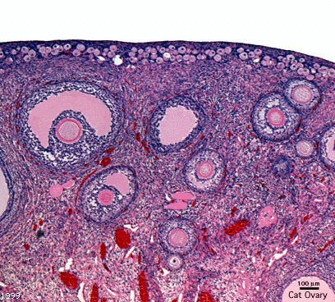 | 2

Outline the processes involved in oogenesis within the ovary, including  mitosis, .....................................................................................................................................  cell growth, .....................................................................................................................................  the two divisions of meiosis, the .....................................................................................................................................  unequal division of cytoplasm and .....................................................................................................................................  the degeneration of polar body. ..................................................................................................................................... | 2
Draw and label a diagram of a mature sperm.

Draw and label a diagram of a mature egg.

