Using the information below, complete the control-system diagram on the next sheet and answer the questions.
- Sometimes we produce lots of almost colourless urine. It is dilute. That means it has a high water content, but a low concentration of salts and other dissolved substances.
- At other times we produce small amounts of darker coloured urine. It has a lower water content, but a higher concentration of salts.

To do
- Make a list of things which result in your producing a lot of urine. Use this information to complete box B on the next sheet.
- Make a similar list of things which result in your producing a small amount of darker coloured urine. Use this information to complete box A on the next sheet.
- Use the information in the box below to complete your control-system diagram.
The receptors that detect changes in the salt concentration of the blood are in part of your brain called the hypothalamus.
When the salt concentration rises, your hypothalamus causes your pituitary gland to secrete a hormone called ADH (antidiuretic hormone).
The ADH causes your kidney tubules to reabsorb more water into your blood. As a result, less water ends up in your urine.
The action of the hypothalamus also makes you thirsty so that you drink more. The concentration of your urine returns to normal.
When your hypothalamus detects this negative feedback – that the concentration is back to normal – it stops ADH secretion from the pituitary.

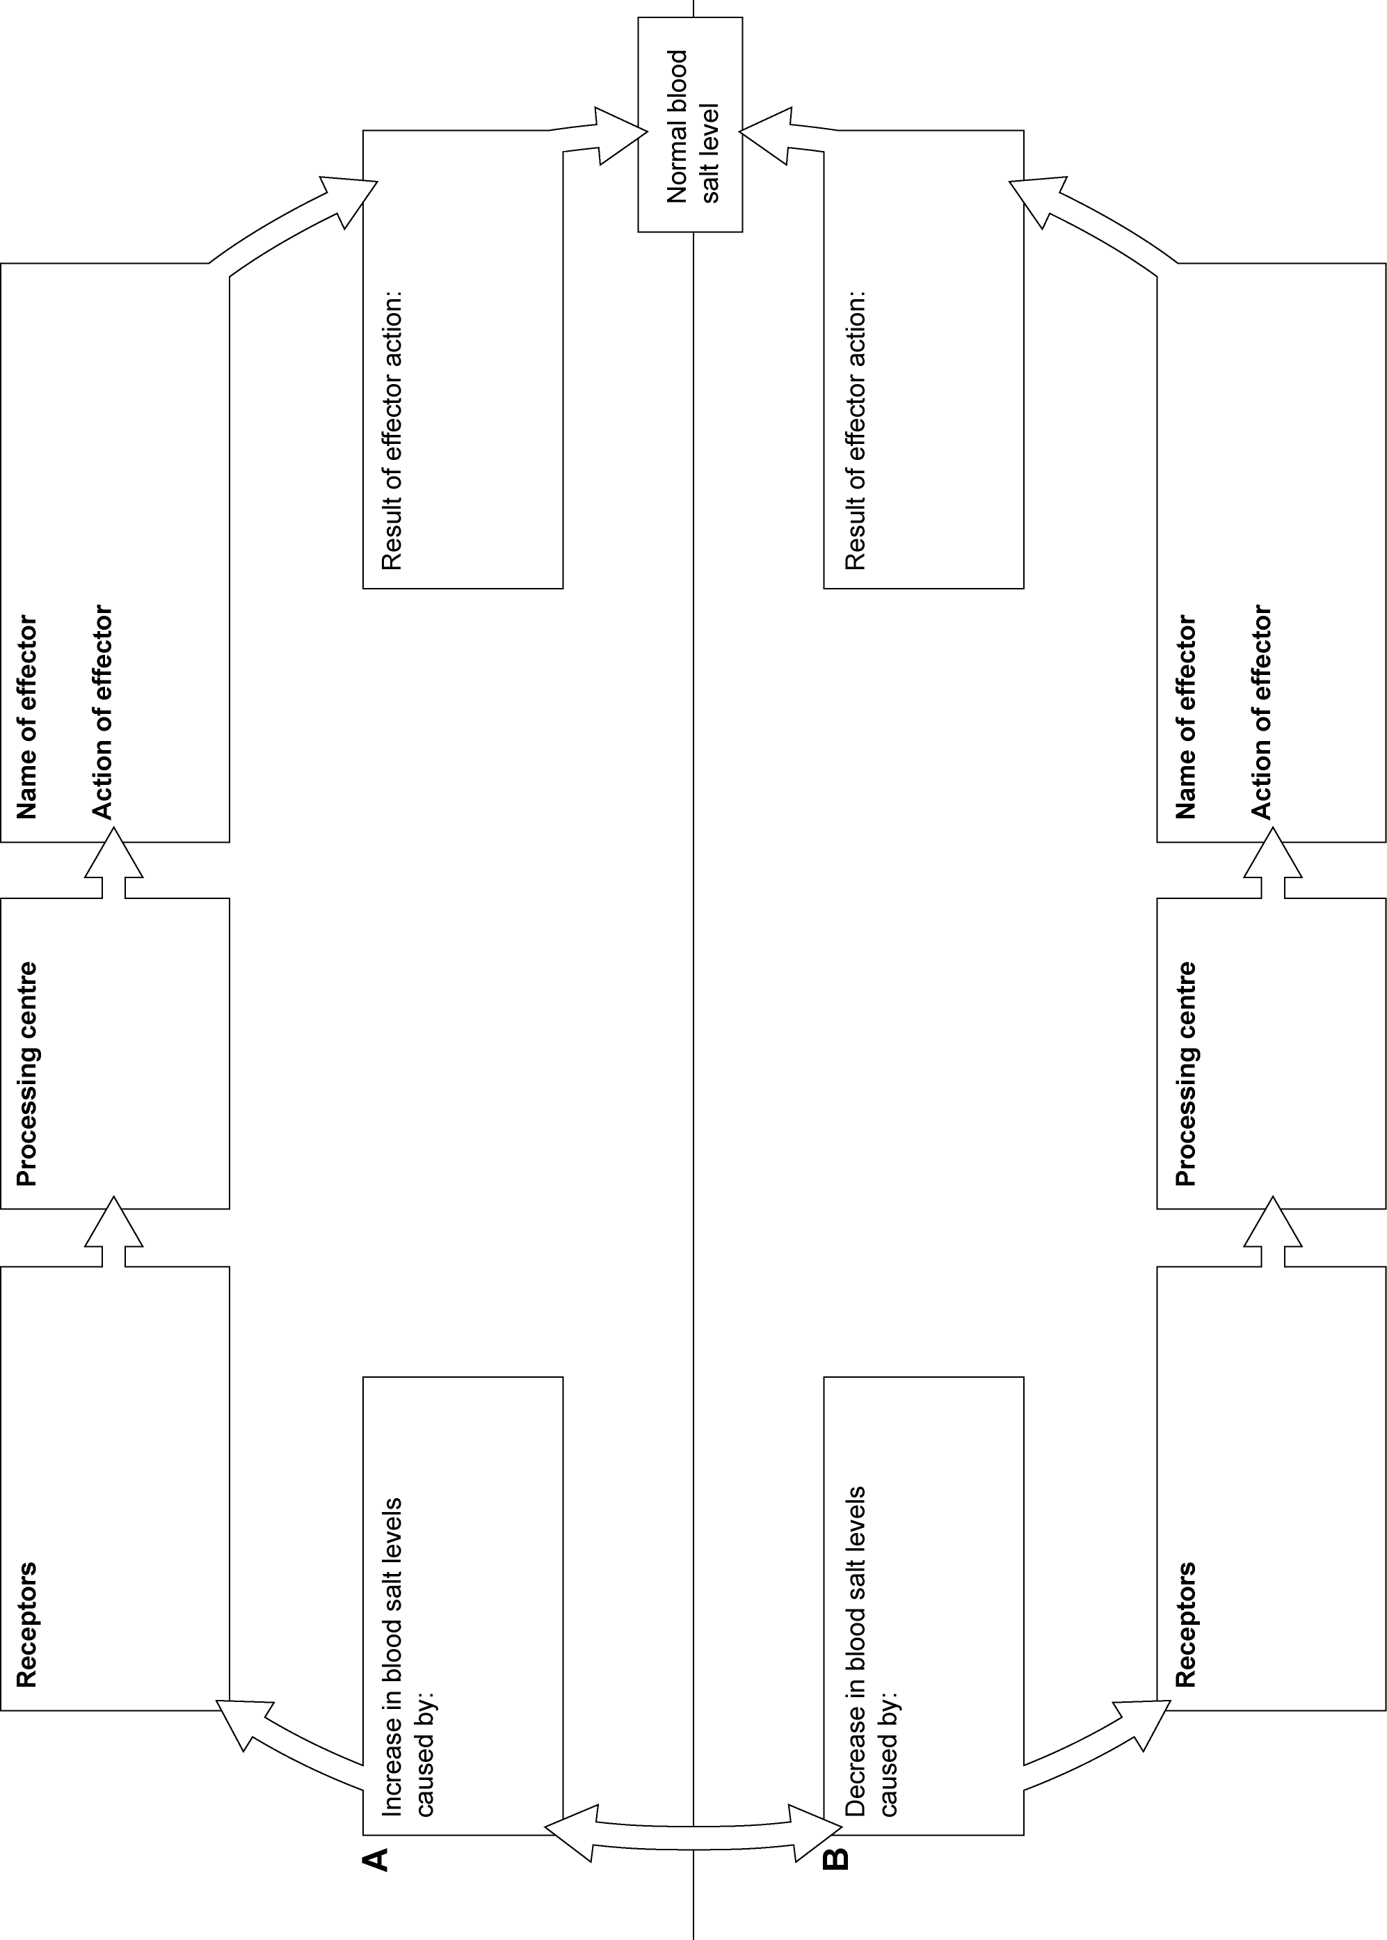

To answer
Use your completed control-system diagram to help you.
- Explain how negative feedback is involved in keeping blood water content constant.
- Diabetes insipidus is a rare disease in which a person stops producing ADH. What is the main symptom you would expect to see in a person with diabetes insipidus? Explain your answer.
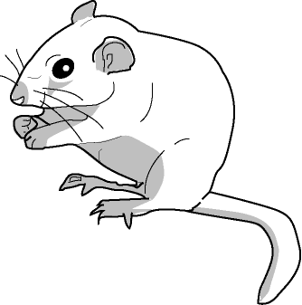
- Gerbils are small mammals that live in deserts. Scientists have found that the concentration of ADH in the blood of a gerbil is higher than in the blood of similar mammals that live in wetter places. Suggest why a high concentration of ADH in the blood may be an advantage to a gerbil.
A gerbil
- People who fly long distances often become dehydrated.
Here is part of a leaflet given to passengers.
Avoiding dehydration on long flights
In flight, the cabin air pressure is reduced. The air in the cabin is also drier than usual. As a result, more water evaporates from your lungs when you breathe out. This can lead to dehydration. You can take several steps to avoid dehydration. In particular, avoid eating salty foods such as peanuts and crisps immediately before flying. Drink plenty of water or soft drinks throughout the flight. Avoid alcoholic drinks.

Explain why passengers are advised:
  - to drink plenty of water or soft drinks
  - to avoid eating salty foods such as peanuts and crisps
  - to avoid alcoholic drinks (Hint: Ethanol prevents the release of ADH.)

