
IB Biology: Topic 5 Revision Booklet Name _______

Topic 6: Human health and physiology (20 hours)

6.1Digestion (3 hours)

6.1.1 Explain why digestion of large food molecules is essential. 3

6.1.2 Explain the need for enzymes in digestion. 3

The need for increasing the rate of digestion at body temperature should be emphasized.

6.1.3 State the source, substrate, products and optimum pH conditions for one amylase, one protease and one lipase. 1

Any human enzymes can be selected. Details of structure or mechanisms of action are not required.

Aim 7: Data logging with pH sensors and lipase, and data logging with colorimeters and amylase can be used.

Enzyme | Source (a gland) | Substrate | Products | Optimum pH

6.1.4 Draw and label a diagram of the digestive system. 1

The diagram should show the mouth, esophagus, stomach, small intestine, large intestine, anus, liver, pancreas and gall bladder. The diagram should clearly show the interconnections between these structures.

6.1.5 Outline the function of the stomach, small intestine and large intestine. 2

6.1.6 Distinguish between absorption and assimilation. 2

6.1.7 Explain how the structure of the villus is related to its role in absorption and transport of the products of digestion. 3

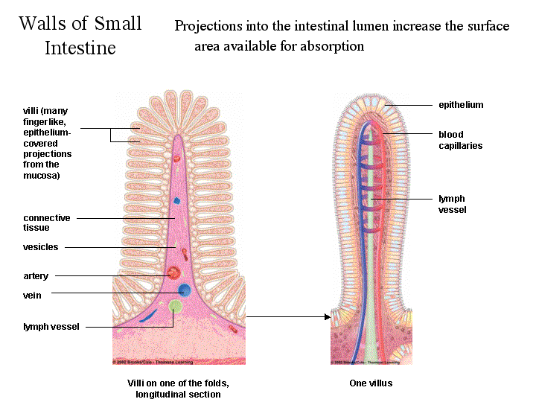

6.2The transport system 3 hours

6.2.1 Draw and label a diagram of the heart showing the four chambers, associated blood vessels, valves and the route of blood through the heart. 1

Care should be taken to show the relative wall thickness of the four chambers. Neither the coronary vessels nor the conductive system are required.

6.2.2 State that the coronary arteries supply heart muscle with oxygen and nutrients.1

6.2.3 Explain the action of the heart in terms of collecting blood, pumping blood, and opening and closing of valves. 3

A basic understanding is required, limited to the collection of blood by the atria, which is then pumped out by the ventricles into the arteries. The direction of flow is controlled by atrio-ventricular and semilunar valves.

6.2.4 Outline the control of the heartbeat in terms of myogenic muscle contraction, the role of the pacemaker, nerves, the medulla of the brain and epinephrine (adrenaline). 2

Histology of the heart muscle, names of nerves or transmitter substances are not required.

Aim 7: Simulation and data logging involving heart rate monitors, or data logging involving an EKG sensor to measure electrical signals produced during muscle contractions, can be used.

6.2.5 Explain the relationship between the structure and function of arteries, capillaries and veins. 3

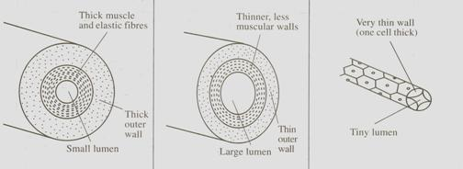

6.2.6 State that blood is composed of plasma, erythrocytes, leucocytes (phagocytes and lymphocytes) and platelets. 1

6.2.7 State that the following are transported by the blood: nutrients, oxygen, carbon dioxide, hormones, antibodies, urea and heat. 1

No chemical details are required.

6.3 Defence against infectious disease 3 hours

6.3.1 Define pathogen. 1

Pathogen: an _____________ or virus that ____________ a disease.

6.3.2 Explain why antibiotics are effective against bacteria but not against viruses. 3

Antibiotics block specific metabolic pathways found in bacteria. Viruses reproduce using the host cell’s metabolic pathways, which are not affected by antibiotics.

Aim 8: The great benefits to people throughout the world in the control of bacterial diseases using antibiotics should be stressed. Examples of diseases that often proved fatal before the advent of antibiotics could be named.

6.3.3 Outline the role of skin and mucous membranes in defence against pathogens. 2

A diagram of the skin is not required.

6.3.4 Outline how phagocytic leucocytes ingest pathogens in the blood and in body tissues. 2

Details of the subdivisions and classifications of phagocytes are not required.

6.3.5 Distinguish between antigens and antibodies. 2

6.3.6 Explain antibody production. 3

Many different types of lymphocyte exist. Each type recognizes one specific antigen and responds by dividing to form a clone. This clone then secretes a specific antibody against the antigen. No other details are required.

6.3.7 Outline the effects of HIV on the immune system. 2

The effects of HIV should be limited to a reduction in the number of active lymphocytes and a loss of the ability to produce antibodies.

6.3.8 Discuss the cause, transmission and social implications of AIDS. 3

Aim 8: The social implications of AIDS are well known. Cases of AIDS are not evenly distributed in the world, and consideration could be given to the severe problems in southern Africa. Cultural and economic reasons for differences in the prevalence of AIDS could be considered. The moral obligation of those with the technology and the wealth to help others lacking these things could be discussed.

TOK: The different methods of transmission of HIV each carry their own risk. The extent to which individuals in different societies can minimize or eliminate each of these risks could be considered.

6.4 Gas exchange 2 hours

6.4.1 Distinguish between ventilation, gas exchange and cell respiration. 2

6.4.2 Explain the need for a ventilation system. 3

A ventilation system is needed to maintain high concentration gradients in the alveoli.

6.4.3 Describe the features of alveoli that adapt them to gas exchange. 2

This should include a large total surface area, a wall consisting of a single layer of flattened cells, a film of moisture and a dense network of capillaries.

6.4.4 Draw and label a diagram of the ventilation system, including trachea, lungs, bronchi, bronchioles and alveoli. 1

Students should draw the alveoli in an inset diagram at a higher magnification.

6.4.5 Explain the mechanism of ventilation of the lungs in terms of volume and pressure changes caused by the internal and external intercostal muscles, the diaphragm and abdominal muscles. 3

6.5 Nerves, hormones and homeostasis 6 hours

6.5.1 State that the nervous system consists of the central nervous system (CNS) and peripheral nerves, and is composed of cells called neurons that can carry rapid electrical impulses. 1

No other structural or functional divisions of the nervous system are required.

6.5.2 Draw and label a diagram of the structure of a motor neuron. 1

Include dendrites, cell body with nucleus, axon, myelin sheath, nodes of Ranvier and motor end plates.

6.5.3 State that nerve impulses are conducted from receptors to the CNS by sensory neurons, within the CNS by relay neurons, and from the CNS to effectors by motor neurons. 1

6.5.4 Define resting potential and action potential (depolarization and repolarization). 1

6.5.5 Explain how a nerve impulse passes along a non-myelinated neuron. 3

Include the movement of Na+ and K+ ions to create a resting potential and an action potential.

6.5.6 Explain the principles of synaptic transmission. 3

Include the release, diffusion and binding of the neurotransmitter, initiation of an action potential in the post-synaptic membrane, and subsequent removal of the neurotransmitter.

6.5.7 State that the endocrine system consists of glands that release hormones that are transported in the blood. 1

The nature and action of hormones or direct comparisons between nerve and endocrine systems are not required.

6.5.8 State that homeostasis involves maintaining the internal environment between limits, including blood pH, carbon dioxide concentration, blood glucose concentration, body temperature and water balance. 1

The internal environment consists of blood and tissue fluid.

6.5.9 Explain that homeostasis involves monitoring levels of variables and correcting changes in levels by negative feedback mechanisms. 3

6.5.10 Explain the control of body temperature, including the transfer of heat in blood, and the roles of the hypothalamus, sweat glands, skin arterioles and shivering.3

Aim 7: Data logging using a surface temperature sensor to investigate the warming by nasal passages could be carried out here.

6.5.11 Explain the control of blood glucose concentration, including the roles of glucagon, insulin and α and β cells in the pancreatic islets. 3

The effects of adrenaline are not required here.

6.5.12 Distinguish between type I and type II diabetes. 2

Aim 8: Diabetes is having an increasing effect on human societies around the world.

TOK: The causes of the variation in rates of type II diabetes in different human populations could be analysed. Rates can be particularly high when individuals consume a diet very different to the traditional one of their ancestors, for example, when having migrated to a new country.

6.6 Reproduction 3 hours

6.6.1 Draw and label diagrams of the adult male and female reproductive systems. 1

The relative positions of the organs is important. Include the bladder and urethra.

6.6.2 Outline the role of hormones in the menstrual cycle, including FSH (follicle stimulating hormone), LH (luteinizing hormone), estrogen and progesterone. 2

6.6.3 Annotate a graph showing hormone levels in the menstrual cycle, illustrating the relationship between changes in hormone levels and ovulation, menstruation and thickening of the endometrium. 2

6.6.4 List three roles of testosterone in males. 1

Limit this
- to pre-natal development of male _____________,
- development of secondary ___________l characteristics and
- maintenance of ________ drive.

6.6.5 Outline the process of in vitro fertilization (IVF). 2

6.6.6 Discuss the ethical issues associated with IVF. 3

Aim 8: There is great variation between human societies around the world in the views held on IVF. This is the result of cultural and religious diversity. There is little evidence to suggest that children born as a result of standard IVF protocols are different in any way from children conceived naturally. It is important that there is parity of esteem for all children, however they were conceived.

TOK: There are potential risks in the drug treatments that the woman is given, and there are concerns about the artificial selection of sperm and the injection of them into the eggs that occurs with some IVF protocols. The natural selection of sperm with consequent elimination of unhealthy ones is bypassed, and there is evidence that there are higher rates of abnormality in the offspring as a result.

