Blood and Blood Vessels Experiment

Follow the instructions to produce comprehensive notes on blood and blood vessels

Blood Vessels

- Look at the slides of arteries and veins and draw a simple diagram showing the shape, thickness and size of each

- Produce a summary table to compare structure and function of the arteries, veins and capillaries.

Structure | Arteries | Capillaries | Veins
Layers in the wall
Thickness of the muscular layer
Size of the lumen
Presence of valves

- How does the structure of each blood vessel relate to its function?

Blood

- Using the slide produce a diagram of the following cells and add to it their basic functions:
  - Erythrocytes
  - Leucocytes
    - Phagocytes
    - Lymphocytes
  - Platelets (Thrombocytes
  - Plasma – Diagram not needed, but must state its composition including the substances that it transports
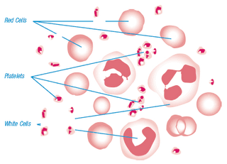
Name the cells in the diagram below
