Remember
- Ribosomes make proteins.
- They use the mRNA code to get the amino acids in the correct order.
- The code is a triplet code – 3 bases code for one amino acid.
In this activity, you are making a protein. See whether you can be the first to finish.
- Read the first 3 bases of your mRNA code.
AUG-UUC-AGU-AGA-GUC-CUG-GCC-UAA
- Look up the triplet code on this RNA codes table to find out which amino acid it is the code for.
 |  | SECOND BASE
 |  | U |  | C |  | A |  | G
F  I  R  S  T  B  A  S  E | U | UUU | Phe | UCU | Ser | UAU | Tyr | UGU | Cys | U | T  H  I  R  D  B  A  S  E
F  I  R  S  T  B  A  S  E | U | UUC | Phe | UCC | Ser | UAC | Tyr | UGC | Cys | C | T  H  I  R  D  B  A  S  E
F  I  R  S  T  B  A  S  E | U | UUA | Leu | UCA | Ser | UAA | Stop | UGA | Stop | A | T  H  I  R  D  B  A  S  E
F  I  R  S  T  B  A  S  E | U | UUG | Leu | UCG | Ser | UAG | Stop | UGG | Trp | G | T  H  I  R  D  B  A  S  E
F  I  R  S  T  B  A  S  E | C | CUU | Leu | CCU | Pro | CAU | His | CGU | Arg | U | T  H  I  R  D  B  A  S  E
F  I  R  S  T  B  A  S  E | C | CUC | Leu | CCC | Pro | CAC | His | CGC | Arg | C | T  H  I  R  D  B  A  S  E
F  I  R  S  T  B  A  S  E | C | CUA | Leu | CCA | Pro | CAA | Gla | CGA | Arg | A | T  H  I  R  D  B  A  S  E
F  I  R  S  T  B  A  S  E | C | CUG | Leu | CCG | Pro | CAG | Gla | CGG | Arg | G | T  H  I  R  D  B  A  S  E
F  I  R  S  T  B  A  S  E | A | AUU | lle | ACU | Thr | AAU | Asn | AGU | Ser | U | T  H  I  R  D  B  A  S  E
F  I  R  S  T  B  A  S  E | A | AUC | lle | ACC | Thr | AAC | Asn | AGC | Ser | C | T  H  I  R  D  B  A  S  E
F  I  R  S  T  B  A  S  E | A | AUA | lle | ACA | Thr | AAA | Lys | AGA | Arg | A | T  H  I  R  D  B  A  S  E
F  I  R  S  T  B  A  S  E | A | AUG | Met | ACG | Thr | AAG | Lys | AGG | Arg | G | T  H  I  R  D  B  A  S  E
F  I  R  S  T  B  A  S  E | G | GUU | Val | GCU | Ala | GAU | Asp | GGU | Gly | U | T  H  I  R  D  B  A  S  E
F  I  R  S  T  B  A  S  E | G | GUC | Val | GCC | Ala | GAC | Asp | GGC | Gly | C | T  H  I  R  D  B  A  S  E
F  I  R  S  T  B  A  S  E | G | GUA | Val | GCA | Ala | GAA | Glu | GGA | Gly | A | T  H  I  R  D  B  A  S  E
F  I  R  S  T  B  A  S  E | G | GUG | Val | GCG | Ala | GAG | Glu | GGG | Gly | G | T  H  I  R  D  B  A  S  E
- Copy the letters which represents this amino acid into the diagram below.
- Now read the next triplet and add the next bead to your string.
- Continue until you have read the whole code and your ‘protein’ is complete.
- Ask your teacher to check it.

To answer
- How many different amino acids are in proteins?
- How many different codes are there in the mRNA table of genetic codes?
- Some amino acids have more than one code. Look at the table of mRNA codes to find the highest number of codes for any one amino acid. Name the amino acid.
- How many different triplets are there in your mRNA sequence?
- How many different amino acids were there in your protein?
- Explain why these two numbers are different.
- If a haemoglobin molecule is a sequence of 141 amino acids, how many mRNA bases are needed to code for it?
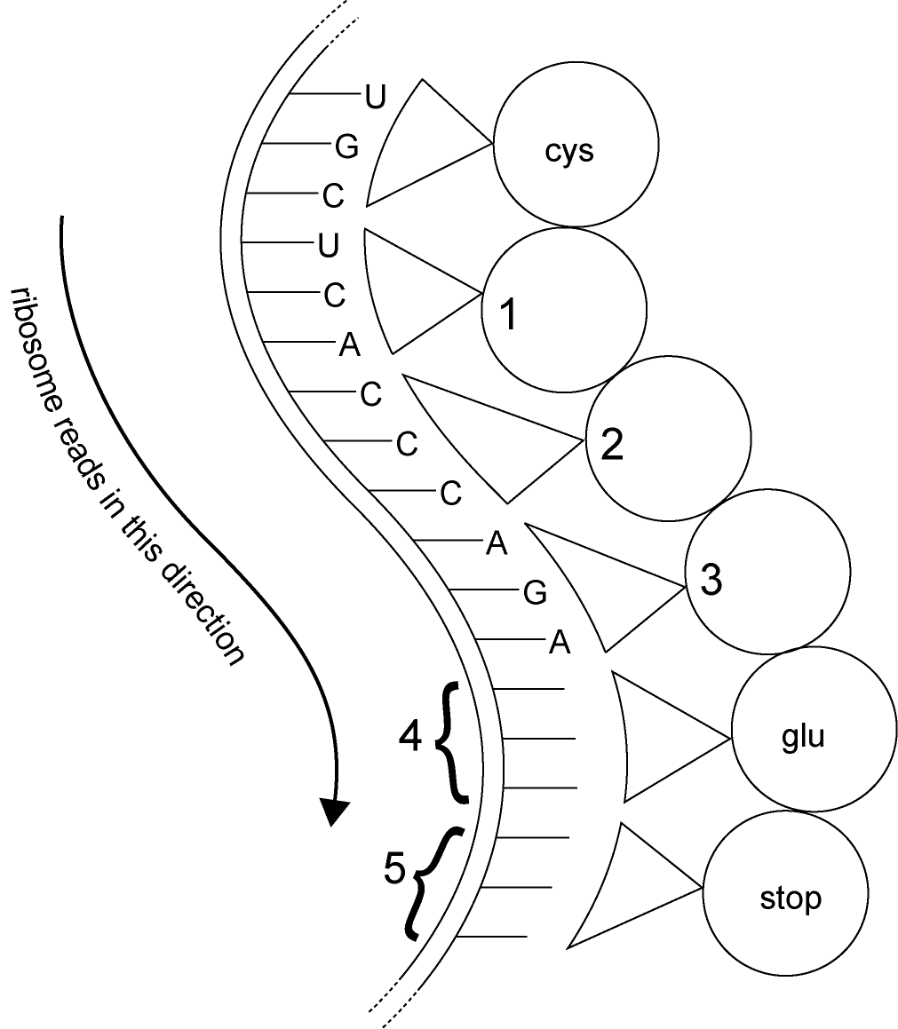
- a Use the table of RNA codes to work out
the missing amino acid codes
(1, 2 and 3) in the diagram.
b Use the table of RNA codes to work out
the mRNA bases forming the triplets
4 and 5 in the diagram. There
may be more than one correct answer
– you just give one correct alternative.

Optional
- Real ribosomes join up amino acids to make protein at the rate of about 10 amino acids per second (= 0.1 seconds for each amino acid).
Record how many seconds you took to do yours.
Work out how many times faster the real ribosome works.
- There are lots of ribosomes in the cytoplasm. Suggest how having lots of ribosomes can speed up making proteins.

