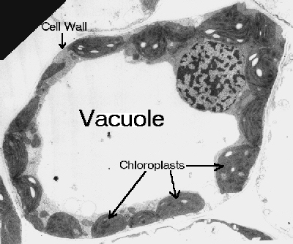

- The pressure applied by the vacuole, called turgor, is necessary to maintain the size of the cell.
- Are large in size, contains cell sap made of salt water.
- Responsible for maintaining the shape and structure of the cell.
- Used to store nutrients, metabolites, and waste products.
- The vacuole typically is 50% of the volume of the cell, yet it can take up to 95% of the cell!

