12 Important Features of CELLS
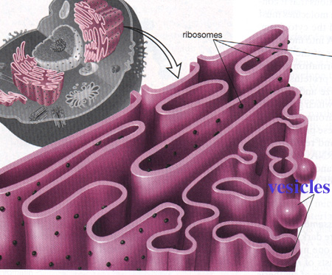
Rough Endoplasmic Reticulum:
- Consists of layers of membranes
- It is connected to the nuclear membrane, and has ribosomes attached to it.
- After the ribosomes make proteins, it isolates and transports them.
- Has a large surface area, which allows space for all of the proteins, also makes space for storage and transport of the proteins.
- Any cell that has to secrete a lot of material (like digestive cells in the stomach) will have a lot of rough endoplasmic reticulum.

