Ribosome

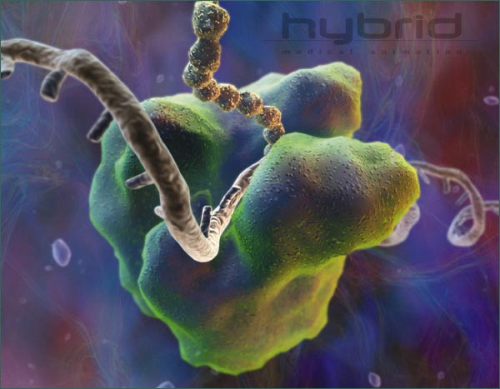

- These are cytoplasmic organelles.
- Granules found on rough endoplasmic reticulum
- Makes protein
- They can be found in two ways, free and bound to membranes.
- Free ribosomes are found cytosol and occur in greater numbers than bound ribosomes. These make proteins, which go into solution in the cytoplasm.
- Bound ribosomes are bound on the rough endoplasmic reticulum and make the proteins for membranes or cell exterior.

