SMOOTH ENDOPLASMIC RETICULUM

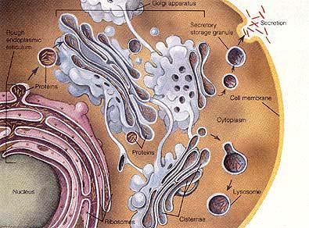
- Makes lipids
- It is involved in the synthesis and transport of fatty molecules such as steroids and lipids
- It is made up of membranes
- Linked to the nucleus membrane
- Some are tubular shaped and some are sac shaped

