Lysosomes

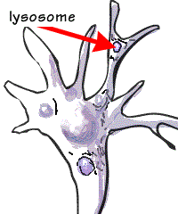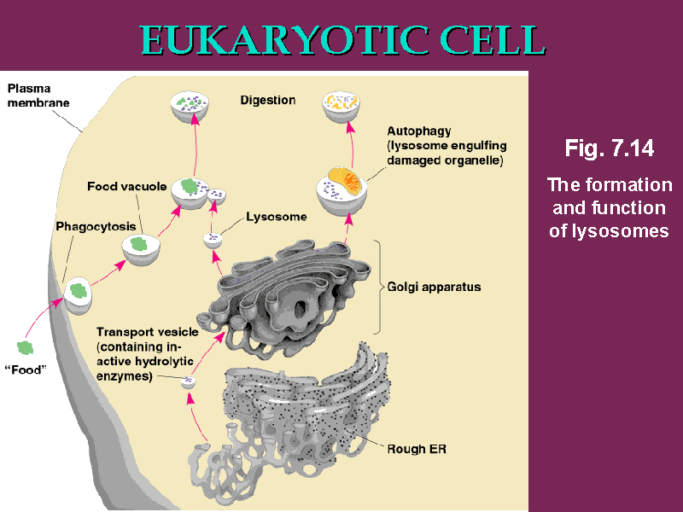

- Lysosomes are dark, spherical bodies in the cytoplasm
- Contain a powerful mix of digestive enzymes,
- Destroys organelles in a cell that have become worn out.
- Often fuse together with membrane bound vacuoles.
- Digests contents into smaller molecules that can be reused

