Cell Membrane

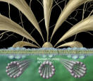
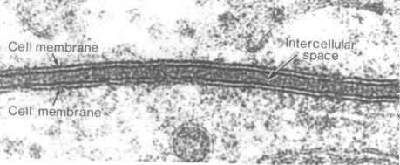

- Cell membrane can also be called cell surface membrane
- It’s the boundary between the cell and it’s environment
- It controls which materials pass in and out of the cell
- They contain proteins that create pores through which water and water-soluble chemicals can pass
- They also contain phospholipids, cholesterol and polysaccharides

