The chloroplast is made up of 3 types of membrane:
- A smooth outer membrane which is freely permeable to molecules.
- A smooth inner membrane which contains many transporters: integral membrane proteins that regulate the passage in an out of the chloroplast of
  - small molecules like sugars
  - proteins synthesized in the cytoplasm of the cell but used within the chloroplast
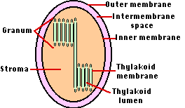
- A system of thylakoid membranes
4. Contain chlorophyll

