 | International School of Toulouse  Centre No. 1203 | IB Biology | SL / HL .. (circle one)
Expt No. 001 | Title: Calculating Cell Size |  | Time /h: 2 Hour
IB Syll Ref : 1.2 | Student Name: ____________________________________ |  | Date: _______
Assessment of ................. DCP: ______ (practice only) C &E: ______ MS: ______

Apparatus
Each student will need the following apparatus:
- a microscope with 4x, 10x and 40x objectives
- a small plastic ruler
- a cotton bud
- a dropping pipette
- fine tweezers
- two slides and coverslips
- live material of moss leaves, and /or onion cells
- access to methaline blue stain, iodine, a stage graticule and 500ml of steralising solution (for cheek cell & cotton bud disposal)
Aims are to learn how to:
- Estimate the sizes of cells
- Record measurements to IB standards in a results table.
- Use Excel to plot bar graphs
- Use values of standard deviation
- Calculate the T-test.

Methods

Making slides of Moss leaves

Drawing & measuring cells.

Human cheek cells
- Add one drop of methylene blue to the middle of a clean slide.
Be careful! Methylene blue will stain your clothes and skin.
- Use the flat side of a toothpick to gently rub the inside of your cheek. DO NOT GOUGE YOUR CHEEK
- Gently touch the toothpick to the drop of dye on the slide. Some of your cheek cells should drift off into the dye.
- Throw the toothpick into the sterilizing solution.
- Stand a thin glass cover slip on its edge near the drop of dye.
- Slowly lower the other side of the cover slip until it covers the dye completely.
- Using the x4 objective lens, place the slide onto the stage of the microscope.
- Look through the eyepiece and turn the coarse focus knob (the largest knob) until an image comes into focus. It should look like scattered blue blobs.
- Use the fine focus knob (the smallest knob) to make the image as focused as possible.
- Draw a picture of what you see. Label the picture. – this is Qualitative data.
- Collect 10 measurements of the sizes of cheek cells. Be as precise as you can
- Record your data in a table.

Calibrating the Eyepiece graticule
Use the graduated slide to calibrate the eyepiece graticule. The slide is marked in parts of a millimeter.
By aligning the two scales as shown below you can work out how big 10 divisions of the eyepiece graticule are.
The graduated slide shows 1mm in 1/100ths of a mm divisions.
1/100th mm = 10 micrometres
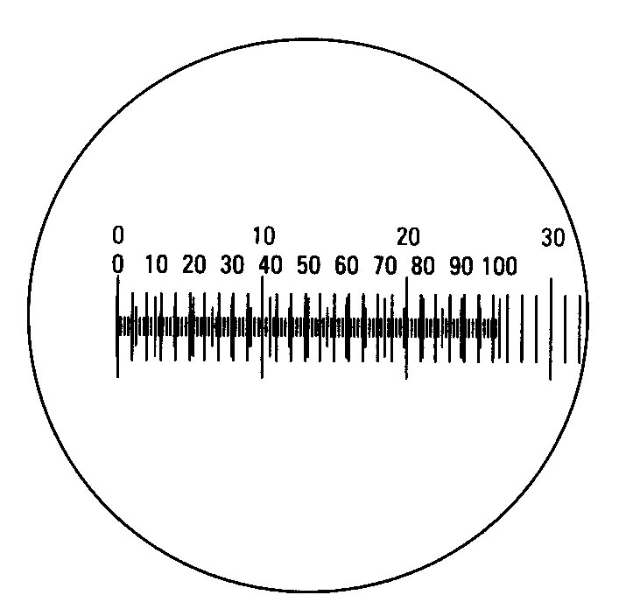
Aligned eyepiece graticule scale with stage micrometer
Calculate the size of one unit in your eyepiece graticule at each magnification you use.
Now you can convert your readings into absolute units of length.

Results
Using excel make a table of raw data from the cheek cells and the moss cells
Make another table of calculated data – using the calibration.

